|  |
| --- |
|  |
| How to Install and Deploy Wazuh in a Network |
|  |

|  |
| --- |
| Written by Christopher Cox |

Contents

Introduction and Resources 1

Configuring Communications 2

Indexer (for Linux) 3

Server 8

Dashboard 9

Agents 12

Linux Agent 12

Windows Agent 15

## Introduction and Resources

The Wazuh platform consists of a server (which also contains a dashboard) that manages the system and the endpoints where agents are installed to actively monitor devices. For this system, the following specifications are in place:

* 1x Linux-based Wazuh server and web-based Wazuh dashboard
* 2x Linux-based Wazuh agents
* 1x Windows-based Wazuh agent

All software and instructions can be found on the Wazuh documentation site (<https://documentation.wazuh.com/current/index.html>), along with alternative methods, upgrade guides, integration guides, and more. This document aims to compile the instructions specific to this project and provide a streamlined and concise guide. Further commands and actions are elaborated based off the experience of creating the network system in this project.

File editing is necessary for the installation. In these examples, Nano was used to edit the configuration files on the Linux machines, however other text editors are suitable if preferred. For other applications, you may replace ‘nano’ with the respective command.

## Configuring Communications

Before starting, it’s important to ensure that the ports are open to allow both inbound and outbound connections to necessary ports that Wazuh requires for communication and operation. Since these machines are created and managed in Azure, we can manage this in the port rules under network settings.

For the server device, we want to ensure HTTP and HTTPS ports are open to inbound connections to access the Wazuh dashboard from an outside source.



Ports 1514 and 1515 should be open to both inbound and outbound connections but only from the required devices. The server’s manager should be open to the agents’ IP address (which may be multiple if multiple agents are deployed). The agents should have the same ports open but only for the server’s IP address.



If the server machine is on Linux and is using UFW for firewall rules, which the system this guide is based off is, it should be ensured that the correct rules are in place here.

This setup can be used with both internal IPs if devices are all on the same network (such as a private internal company network), or public IPs if devices are in outside networks (such as devices in different locations). If you are unsure of your device’s public IP, you can check a device’s address by using the following link:

<https://ipinfo.io/ip>

This can also be run on a Linux machine using CLI with the following command:

“curl https://ipinfo.io/ip”

## Indexer (for Linux)

The indexer is the module that powers the search and analytics capabilities of Wazuh, storing the alerts and rules and navigating through them in operation. This is essentially the foundation of the Wazuh system and is the crucial first step for setting up.

1. **Machine Preparation**

If you are installing this on a new machine, it’s always a good idea to run an update and upgrade first:

“sudo apt update”

“sudo apt upgrade”

1. **Initial configuration and installation**

To initalise the installation, begin with downloading the assistant and configuration files.

“sudo curl -sO https://packages.wazuh.com/4.12/wazuh-install.sh”

“sudo curl -sO https://packages.wazuh.com/4.12/config.yml”



1. **‘config.yml’ File and IPs**

Edit the config.yml file that was just downloaded using your preferred application (For other applications other than Nano, replace ‘nano’ with the respective command).

“sudo nano ./config.yml”

Since this setup consists of a single node cluster with the indexer, server, and dashboard on the same machine, the config file should be updated so the indexer, server, and dashboard use the localhost IP (127.0.0.1). Update the IP field for all three.

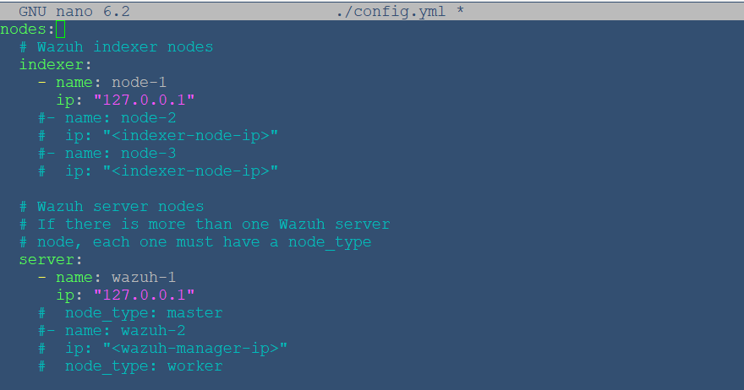

1. **Installation assistant – Run and generate config files**

Run the installation agent with the ‘--generate-config-files’ option with the following command. This will generate a key for the cluster, the certificates for the system, and the passwords for the indexer and dashboard.

“sudo bash wazuh-install.sh --generate-config-files”

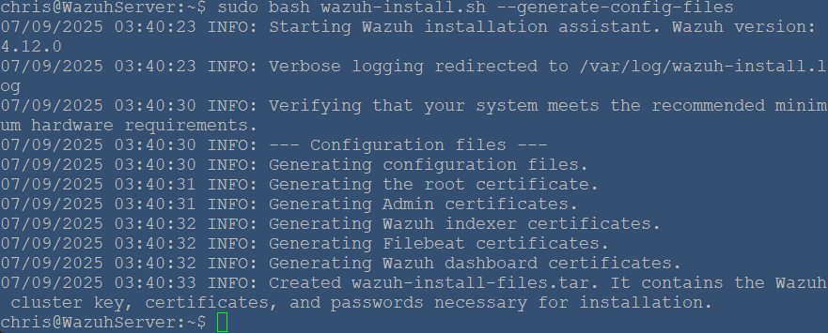

You can see here that ‘wazuh-install-files.tar’ has been created. If this were a multi node cluster between multiple devices, you would have to copy this file over to the separate machines running the other modules. However, with this scale of project, we are using single node cluster where all nodes are on the same machine. Since they can read the same file, copying is not necessary.

1. **Installation agent – Indexer setup**

Now that the initial configuration has been complete, continue to the indexer installation and run the install file with the ‘--wazuh-indexer node-1’ option.

“sudo curl -sO https://packages.wazuh.com/4.12/wazuh-install.sh”

“sudo bash wazuh-install.sh --wazuh-indexer node-1”

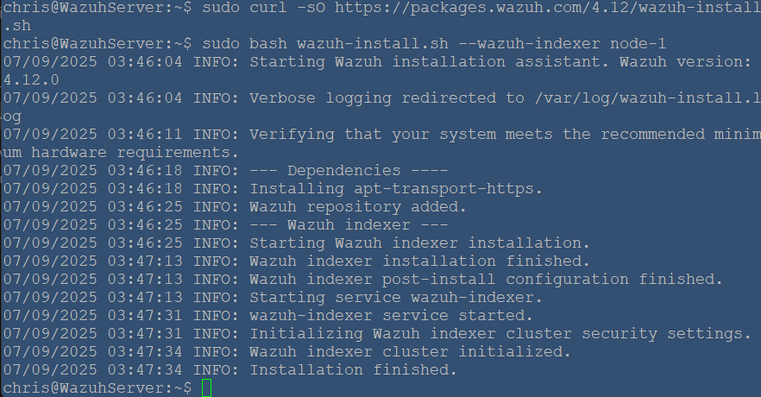

1. **Initialising Cluster**

To start the cluster for this system, run the install file with the ‘--start-cluster’ option.

“sudo bash wazuh-install.sh --start-cluster”

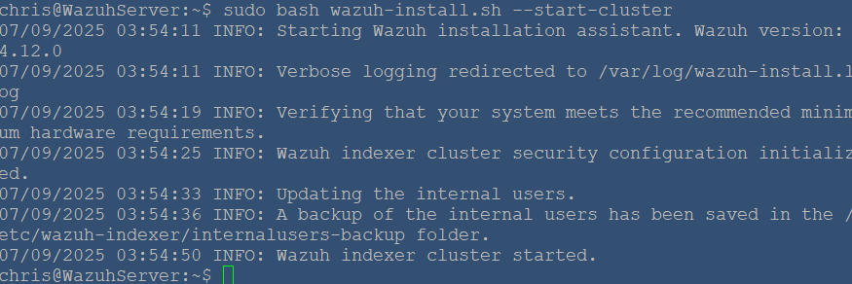

1. **Getting the Admin Password**

At this stage, the admin user (which will always be called ‘admin’) has been created and its password has been generated. It is critical to obtain the admin password and can be done so by running the command below. Take note of this password and keep it recorded somewhere secure.

“sudo tar -axf wazuh-install-files.tar wazuh-install-files/wazuh-passwords.txt -O | grep -P "\'admin\'" -A 1”

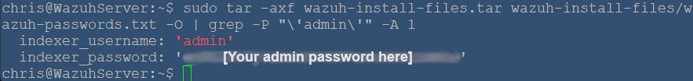

1. **Testing the cluster to see if installation was successful (replace the details below)**

The installation should be successful now, but it should be tested to confirm. To test, the command below should be run, with <ADMIN_PASSWORD> being replaced with the password that was noted down in the previous step.

“sudo curl -k -u admin:<ADMIN_PASSWORD> https://127.0.0.1:9200”

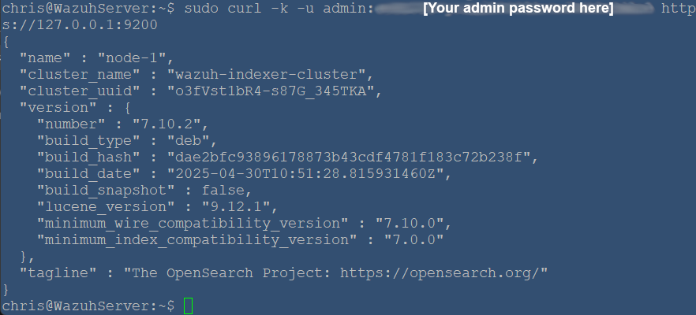

Finally, the cluster should be tested to ensure it is also working correctly. Replace the values in the command like the previous step.

“sudo curl -k -u admin:<ADMIN_PASSWORD> https://<WAZUH_INDEXER_IP>:9200/_cat/nodes?v”

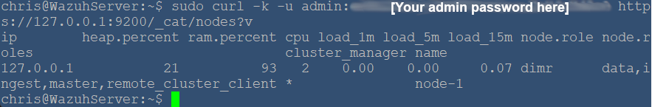

1. **Disabling Updates**

It is recommended directly by Wazuh to disable the Wazuh updates for package repositories once all components are downloaded and installed. This will prevent accidental upgrades that may cause the different modules to be out of sync with each other. The provided commands can be run to disable updates.

“sudo sed -i "s/^deb /#deb /" /etc/apt/sources.list.d/wazuh.list”

“sudo apt update”

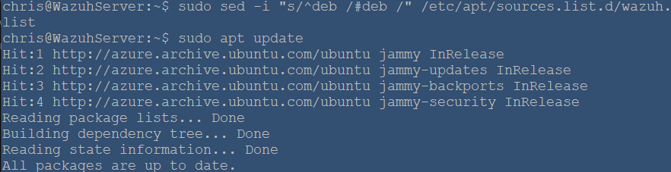

The indexer has now been downloaded and installed, and the installation of the server module can now start.

## Server (for Linux)

1. **Server Installation**

Firstly, ensure the installation assistant is downloaded. Run the installer with the ‘--wazuh-server wazuh-1’ option.

“sudo curl -sO https://packages.wazuh.com/4.12/wazuh-install.sh”

“sudo bash wazuh-install.sh --wazuh-server wazuh-1”

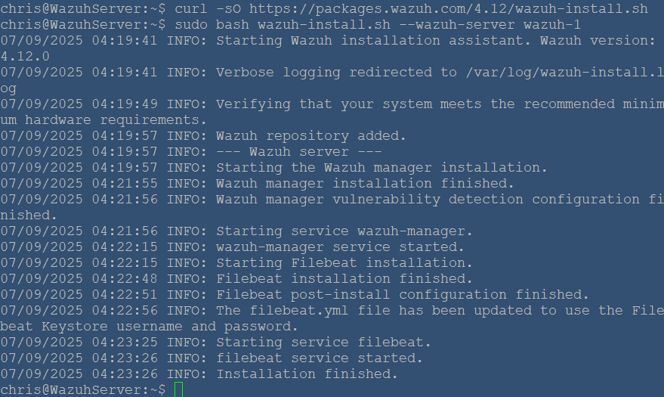

The installation of the server module is now complete. Since this is a single node cluster, we do not have to configure any further server nodes.

1. **Disable Updates**

Once again, it’s important to disable updates as stated in the indexer setup. To confirm updates are disabled, run the commands below.

“sudo sed -i "s/^deb /#deb /" /etc/apt/sources.list.d/wazuh.list”

“sudo apt update”

## Dashboard (for Linux)

1. **Dashboard Installation**

The dashboard is the last essential module in running Wazuh. Begin with running the installation agent with the ‘--wazuh-dashboard dashboard’ option. This may take a few minutes once run, so a small wait can be expected.

“sudo bash wazuh-install.sh --wazuh-dashboard dashboard”

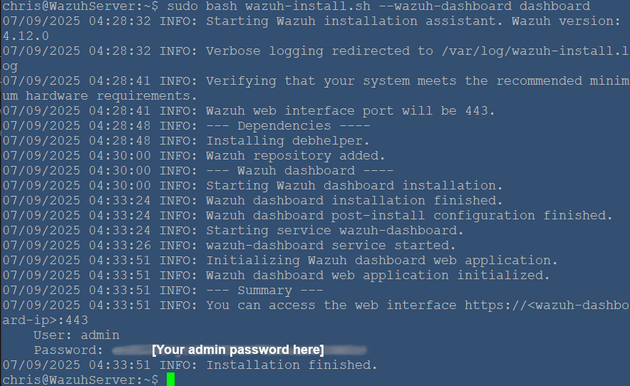

Note that it prints an output showing the dashboard port and admin details. This admin password is the same one that was created for the indexer. If you need to find any associated passwords again, you can find them in the ‘wazuh-passwords.txt’ file using the following command:

“sudo tar -O -xvf wazuh-install-files.tar wazuh-install-files/wazuh-passwords.txt”

1. **Disabling Updates**

Once again, ensure updates are disabled using the same commands as before.

“sudo sed -i "s/^deb /#deb /" /etc/apt/sources.list.d/wazuh.list”

“sudo apt update”

1. **Accessing the Dashboard**

The dashboard is now live and can be connected to using an external browser. Enter your machine’s address into your browser as below, with <PUBLIC_IP> being replaced with the machine’s public IP address.

“https://<PUBLIC_IP>:443”  
  
If you have a safety prompt, you can continue by clicking the advanced option and continuing. You should now see a Wazuh login screen, as pictured below. Enter ‘admin’ in the username field and the password you received earlier into the password field.

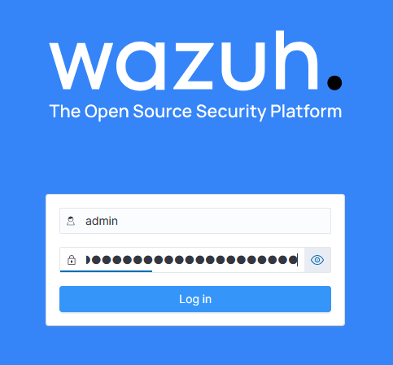

You should now have access to the Wazuh dashboard and view the overview screen as well as browse the other pages in the dashboard.

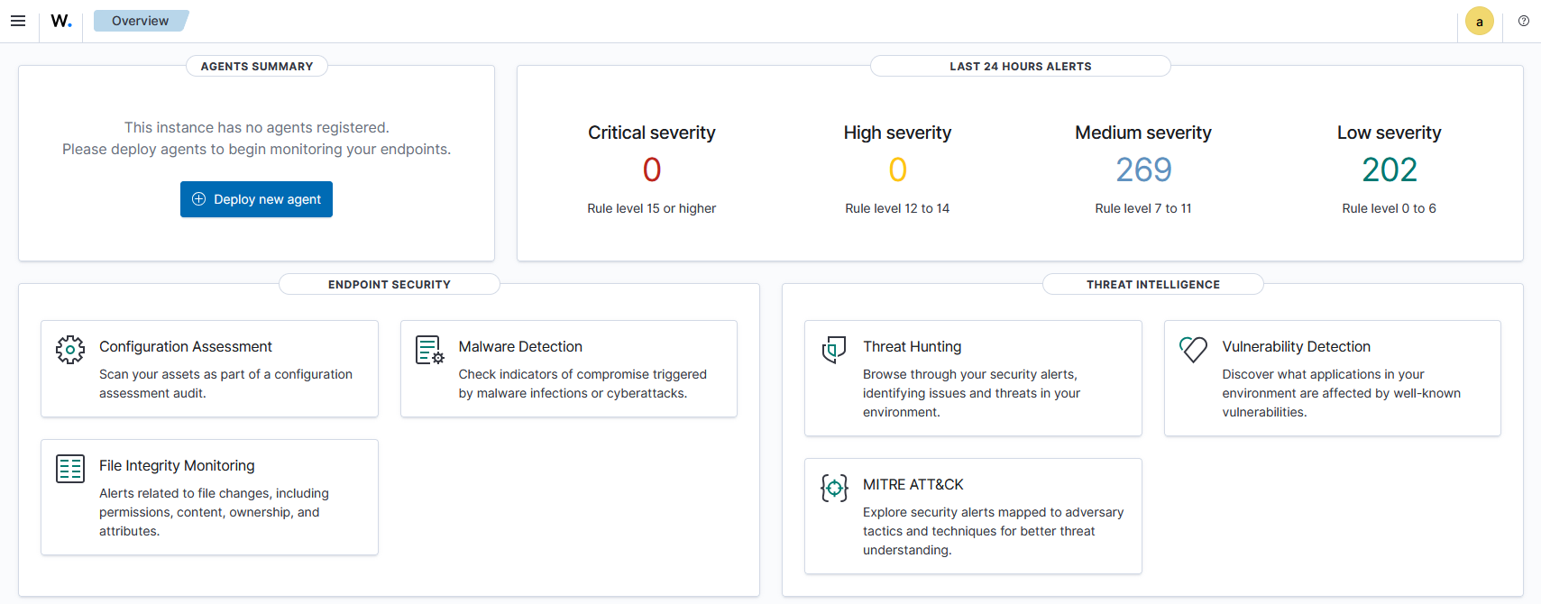

## Agents

Wazuh agent software can be installed on range of different operating systems. For this project and guide, Ubuntu Linux and Windows have been used for agent machines.

It is important to note that network rules on the server machine should be updated to receive communication on newly created agents, as per the Configuring Communications section.

### Linux Agent

1. **Machine Preparation**

If you are installing this on a new machine, it’s always a good idea to run an update and upgrade first:

“sudo apt update”

“sudo apt upgrade”

1. **Installing the GPG key**

Firstly, the GPG key needs to be called to begin the installation. This is done with the command below.

“sudo curl -s https://packages.wazuh.com/key/GPG-KEY-WAZUH | sudo gpg --no-default-keyring --keyring gnupg-ring:/usr/share/keyrings/wazuh.gpg --import && sudo chmod 644 /usr/share/keyrings/wazuh.gpg”

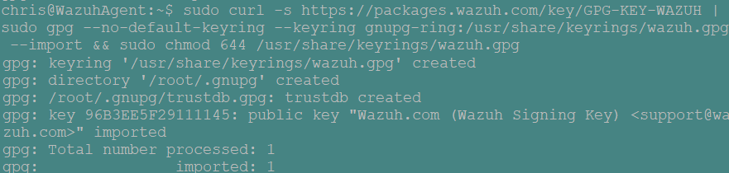

1. **Installing the Repository**

The repository must be downloaded and installed, as this will source the necessary files. The command for this calls on the GPG key and grabs the repository.

“echo "deb [signed-by=/usr/share/keyrings/wazuh.gpg] https://packages.wazuh.com/4.x/apt/ stable main" | sudo tee -a /etc/apt/sources.list.d/wazuh.list”

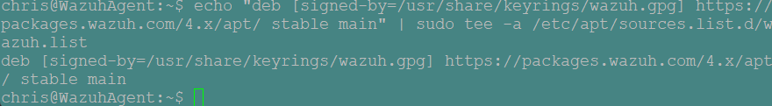

It is important check that the package information is updated by running an update.

“sudo apt-get update”

1. **Agent Deployment**

Now the agent can be deployed. In this command, you must configure the IP it will connect to by replacing <SERVER_IP> with the server’s IP address.

“sudo WAZUH_MANAGER="<SERVER_IP>" apt-get install wazuh-agent”

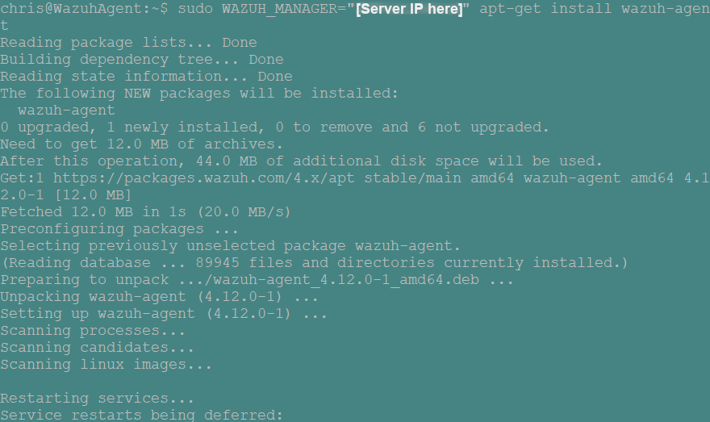

Once this is done, the agent service can now be enabled and started.

“sudo systemctl daemon-reload”

“sudo systemctl enable wazuh-agent”

“sudo systemctl start wazuh-agent”

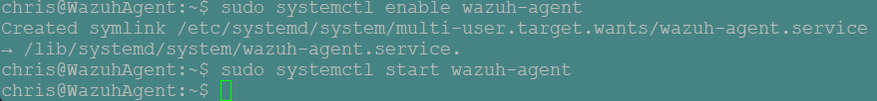

Once again, ensure to disable updates. This will prevent version mismatch between the manager and the agent.

“sudo sed -i "s/^deb/#deb/" /etc/apt/sources.list.d/wazuh.list”

“sudo apt-get update”

Checking the Wazuh dashboard, we can now see the agent is live in the portal and can be viewed. Note that since this agent machine is on the same network as the server, it has detected its internal IP and listed as accordingly.

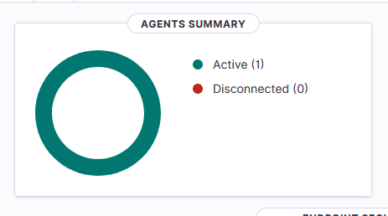

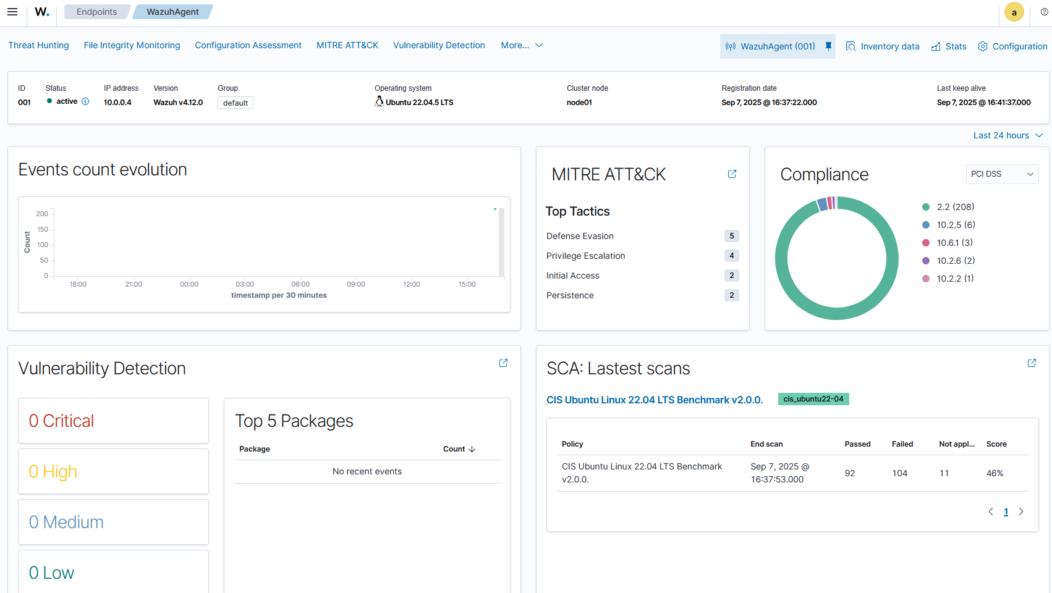

### Windows Agent

1. **Running the Installer**

On the Windows machine, the agent can be installed using the Windows installer file:

<https://packages.wazuh.com/4.x/windows/wazuh-agent-4.12.0-1.msi>



Run this installation file and follow the installation agent.

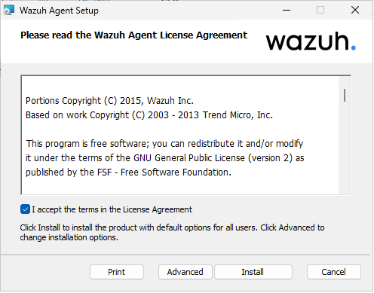

Once it is finished, you can close the window and move onto updating the configuration.

1. **Configuration Update**

Edit the ‘ossec.conf’ file found under C Drive > Program Files (x86) > ossec-agent to update the server IP address.

"File path: C:\Program Files (x86)\ossec-agent\ossec.conf"

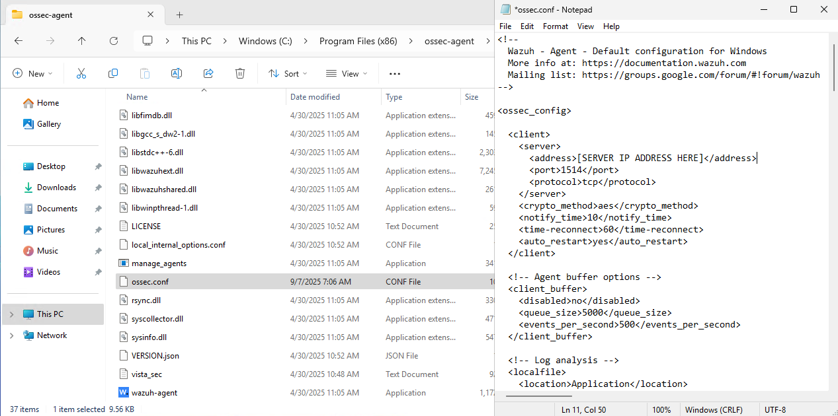

Once done, open Powershell with administrator privileges and run the following command:

“Restart-Service -Name wazuh”

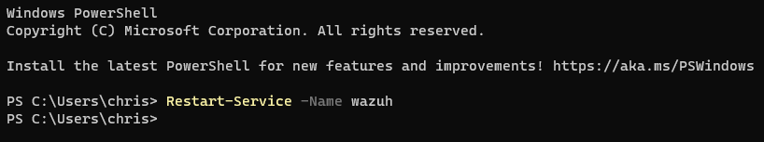

Checking the portal, we can see that the agent has come online and is now registered in the dashboard.

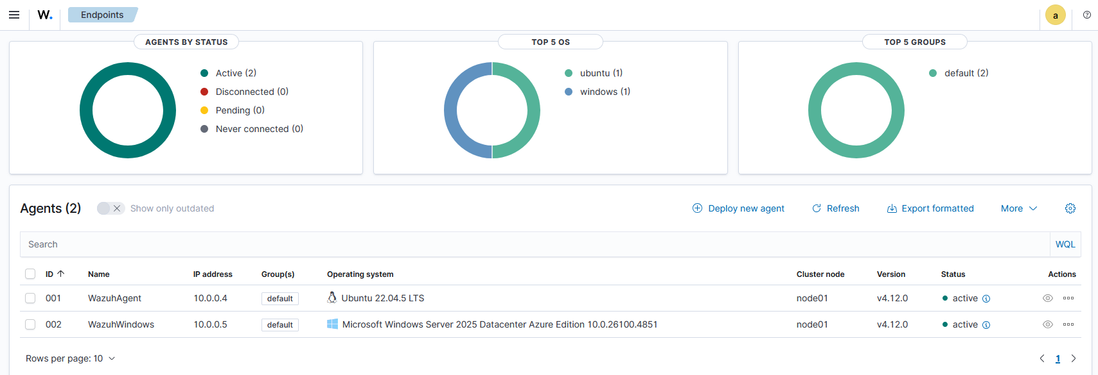

## Helpful Commands

The following commands have been listed as they may be useful in testing and troubleshooting.

### Manager

**Checking Wazuh manager status**

“sudo systemctl status wazuh-manager”

**Enabling, starting and restarting Wazuh manager**

“sudo systemctl enable wazuh-manager”

“sudo systemctl start wazuh-manager”

“sudo systemctl restart wazuh-manager”

**Checking Wazuh manager ossec.log (Last 50 lines)**

“sudo tail -n 50 /var/ossec/logs/ossec.log”

**Uninstalling Wazuh components**

“sudo bash wazuh-install.sh –uninstall” (requires ‘wazuh-install.sh’ file)

OR

“sudo apt-get remove --purge wazuh-dashboard -y”

“sudo apt-get remove --purge wazuh-manager -y”

“sudo apt-get remove --purge filebeat -y”

“sudo apt-get remove --purge wazuh-indexer -y”

### Linux Agent

**Checking Wazuh agent status**

“sudo systemctl status wazuh-agent.service”

**Enabling, starting and restarting Wazuh agent**

“sudo systemctl enable wazuh-agent”

“sudo systemctl start wazuh-agent”

“sudo systemctl restart wazuh-agent”

**Checking Wazuh agent’s ossec.log (Last 50 lines)**

“sudo tail -n 50 /var/ossec/logs/ossec.log”

**Disabling, deleting and purging Wazuh agent and files**

“sudo systemctl disable wazuh-agent”

“sudo apt-get remove wazuh-agent -y”

“sudo apt-get remove --purge wazuh-agent -y”